Cau 1

Code

public class Point {

    private *float* x ;

    private *float* y ;

    public *void* Point2D() {

        x = 0.0f;

        y = 0.0f;

    }

    public *void* Point2D(*float* *x*, *float* *y*) {

*this*.x = *x*;

*this*.y = *y*;

    }

    public *float* getX() {

        return x;

    }

    public *float* getY() {

        return y;

    }

}

public class testPoint {

public static void main(String *args*[]) {

Point point = new Point();

point.Point2D(3, 5);

System.out.println("522H0068 - Pham Van Phuc");

System.out.println("x = " + point.getX());

System.out.println("y = " + point.getY());

}

}

Man hinh chay

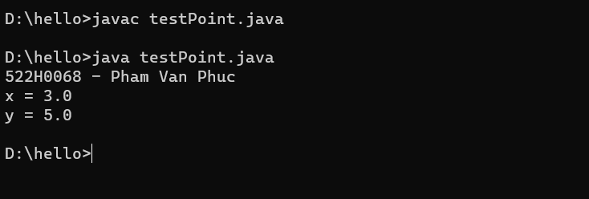

Cau 2

Code :

public class Rectangle {

public float width;

public float length;

public Rectangle() {

width = 1.0f;

length = 1.0f;

}

public Rectangle(float *width*, float *length*) {

*this*.width = *width*;

*this*.length = *length*;

}

public float getWidth() {

return width;

}

public float getLength() {

return length;

}

public float getArea() {

return width \* length;

}

public float getParimeter() {

return 2 \* (width + length);

}

public void setWidth(float *x*) {

*this*.width = *x*;

}

public void setLength(float *y*) {

*this*.length = *y*;

}

@Override

public String toString() {

return "Rectangle [width=" + width + ", length =" + length + "]";

}

}

public class testRectangle {

public static void main(String *args*[]) {

Rectangle tg1 = new Rectangle(5, 10);

System.out.println("522H0068 - Pham Van Phuc");

System.out.println(tg1.getArea());

System.out.println(tg1.getParimeter());

System.out.println(tg1);

}

}

Man hinh chay:

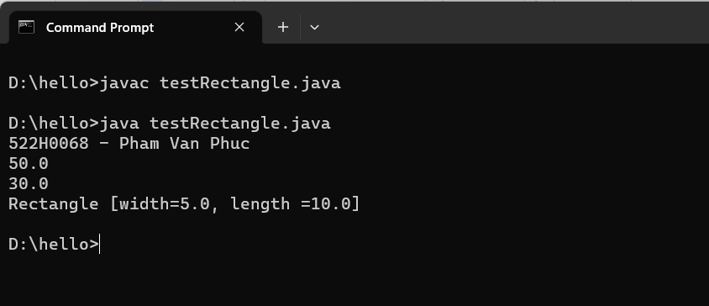

Cau 3

Code :

public class Student {

private int id;

private String firstName;

private String lastName;

public Student(int *id*, String *firstName*, String *lastName*) {

*this*.id = *id*;

*this*.firstName = *firstName*;

*this*.lastName = *lastName*;

}

public int getID() {

return id;

}

public String getFirstName() {

return firstName;

}

public String getLastName() {

return lastName;

}

public void setID(int *id*) {

*this*.id = *id*;

}

public void setFirstName(String *firstName*) {

*this*.firstName = *firstName*;

}

public void setLastName(String *lastName*) {

*this*.lastName = *lastName*;

}

public String getName() {

return firstName + " " + lastName;

}

@Override

public String toString() {

return "Student [id = " + id + ", firstName = " + firstName + ", lastName = " + lastName + "]";

}

}

public class testStudent {

public static void main(String *args*[]) {

System.out.println("522H0068 - PhamVanPhuc");

Student st1 = new Student(522, "Phuc", "Pham");

System.out.println("First name is " + st1.getFirstName());

System.out.println("Last name is " + st1.getLastName());

System.out.println("ID : " + st1.getID());

System.out.println(st1);

}

}

Man hinh chay

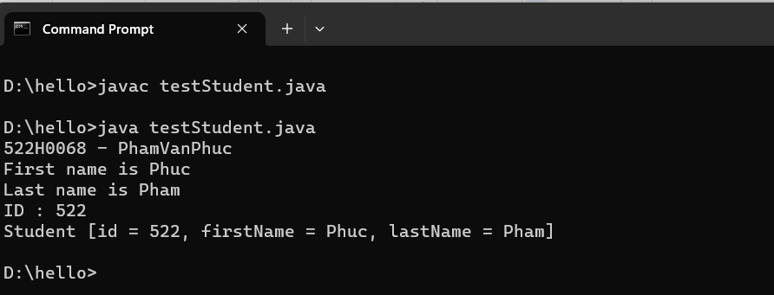

Cau 4 :

Code :

public class House {

private String houseCode;

private int numOfBedRoom;

private boolean hasSwimmingPool;

private double area;

private double costPerSquareMeter;

public House() {

*this*.houseCode = "A01";

*this*.numOfBedRoom = 2;

*this*.hasSwimmingPool = false;

*this*.area = 0;

*this*.costPerSquareMeter = 0;

}

public House(String *houseCode*, int *numOfBedRooms*, boolean *hasSwimmingPool*, double *area*, double *costPerSquareMeter*) {

*this*.houseCode = *houseCode*;

*this*.numOfBedRoom = *numOfBedRooms*;

*this*.hasSwimmingPool = *hasSwimmingPool*;

*this*.area = *area*;

*this*.costPerSquareMeter = *costPerSquareMeter*;

}

public void setHouseCode(String *houseCode*) {

*this*.houseCode = *houseCode*;

}

public String getHouseCode() {

return houseCode;

}

public void setNumOfBedRoom(int *numOfBedRoom*) {

*this*.numOfBedRoom = *numOfBedRoom*;

}

public int getNumOfBedRoom() {

return numOfBedRoom;

}

public void setHasSwimmingPool(boolean *hasSwimmingPool*) {

*this*.hasSwimmingPool = *hasSwimmingPool*;

}

public boolean getHasSwwimmingPool() {

return hasSwimmingPool;

}

public void setArea(double *area*) {

*this*.area = *area*;

}

public double getArea() {

return area;

}

public void setCostPerSquareMeter(double *costPerSquareMeter*) {

*this*.costPerSquareMeter = *costPerSquareMeter*;

}

public double getCostPerSquareMeter() {

return costPerSquareMeter;

}

public double caculateSellingPrice() {

double s = 0;

s = area \* costPerSquareMeter;

if (hasSwimmingPool == true) {

s = s + s \* (1 / 10);

}

s = s + s \* (15 / 100);

return s;

}

@Override

public String toString() {

return "House[" + houseCode + "," + numOfBedRoom + "," + hasSwimmingPool + "," + caculateSellingPrice() + "]";

}

}

public class testHouse {

public static void main(String *args*[]) {

System.out.println("522H0068 - PhamVanPhuc");

House house = new House("PP1803", 3, true, 100, 25000);

System.out.println("Cost selling = " + house.caculateSellingPrice());

System.out.println(house);

}

}

Man hình chạy :

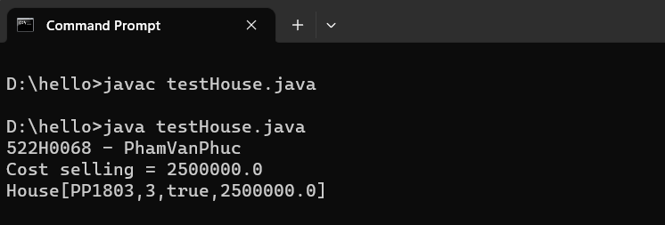

Cau 5

Code

Class Fraction :

public class Fraction {

private int numerator;

private int denominator;

public Fraction(int *num*, int *den*) {

*this*.numerator = *num*;

*this*.denominator = *den*;

}

public Fraction() {

}

public void setNumerator(int *num*) {

*this*.numerator = *num*;

}

public int getNumerator() {

return numerator;

}

public void setDenominator(int *den*) {

*this*.denominator = *den*;

}

public int getDenominator() {

return denominator;

}

public int timUSCLN(int *a*, int *b*) {

while (*a* != *b*) {

if (*a* > *b*) {

*a* -= *b*;

} else {

*b* -= *a*;

}

}

return *a*;

}

public Fraction toiGianPS() {

int i = timUSCLN(Math.abs(numerator), Math.abs(denominator));

int a = (numerator / i);

int b = (denominator / i);

return new Fraction(a, b);

}

public Fraction add(Fraction *ps*) {

int num = (*this*.numerator \* *ps*.denominator) + (*ps*.numerator \* *this*.denominator);

int den = *this*.denominator \* *ps*.denominator;

return new Fraction(num, den);

}

public Fraction sub(Fraction *ps*) {

int num = (*this*.numerator \* *ps*.denominator) - (*ps*.numerator \* *this*.denominator);

int den = *this*.denominator \* *ps*.denominator;

return new Fraction(num, den);

}

public Fraction mul(Fraction *ps*) {

int num = *this*.numerator \* *ps*.numerator;

int den = *this*.denominator \* *ps*.denominator;

return new Fraction(num, den);

}

public Fraction div(Fraction *ps*) {

int num = *this*.numerator \* *ps*.denominator;

int den = *this*.denominator \* *ps*.numerator;

return new Fraction(num, den);

}

@Override

public String toString() {

return "Fraction [num = " + numerator + ", den = " + denominator + "]";

}

}

Class testFraction :

import java.util.Scanner;

public class testFraction {

public static void main(String *args*[]) {

Scanner sc = new Scanner(System.in);

int a, b;

Fraction ps = new Fraction();

System.out.println("522H0068 - Pham Van Phuc");

// Nhap vao phan so

System.out.println("Nhap phan so thu nhat. Tu so va mau so : ");

a = sc.nextInt();

b = sc.nextInt();

Fraction ps1 = new Fraction(a, b);

System.out.println("Nhap phan so thu hai. Tu so va mau so : ");

a = sc.nextInt();

b = sc.nextInt();

Fraction ps2 = new Fraction(a, b);

// tinh toan

System.out.println("Phan so thu nhat vua nhap la : ");

System.out.println(ps1);

System.out.println("Phan so thu hai vua nhap la : ");

System.out.println(ps2);

System.out.println("Tong hai phan so la : ");

ps = (ps1.add(ps2)).toiGianPS();

System.out.println(ps);

System.out.println("Hieu hai phan so la : ");

ps = (ps1.sub(ps2).toiGianPS());

System.out.println(ps);

System.out.println("Tich hai phan so la : ");

ps = (ps1.mul(ps2).toiGianPS());

System.out.println(ps);

System.out.println("Thuong hai phan so la : ");

ps = (ps1.div(ps2).toiGianPS());

System.out.println(ps);

sc.close();

}

}

Man hinh chay :

